**ASSIGNMENT - 8**

**PROBLEM STATEMENT -Deploy a project from local machine to github & vice versa.**

**To Deploy the Project on github**

STEP 1- Create a GitHub account

STEP 2- Click on “New”.

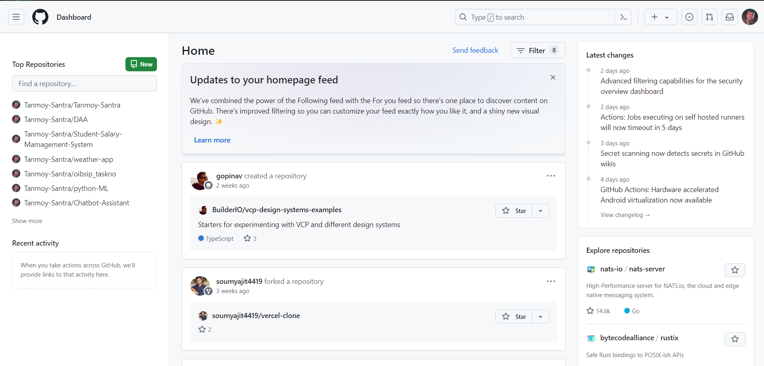

STEP 3- Give a Name & make it public. Then click on Create Repository.

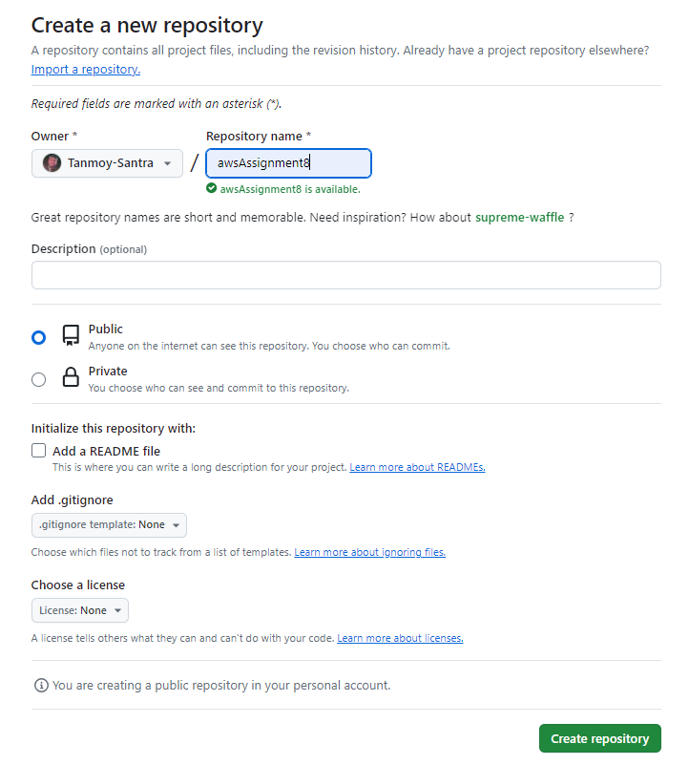

STEP 4- Click on the Profile button, select Settings.

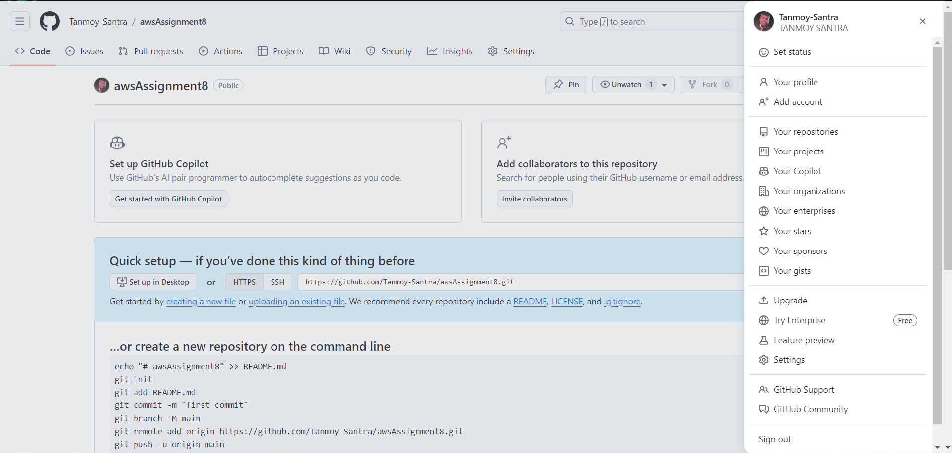

STEP 5- Select Developers Settings.

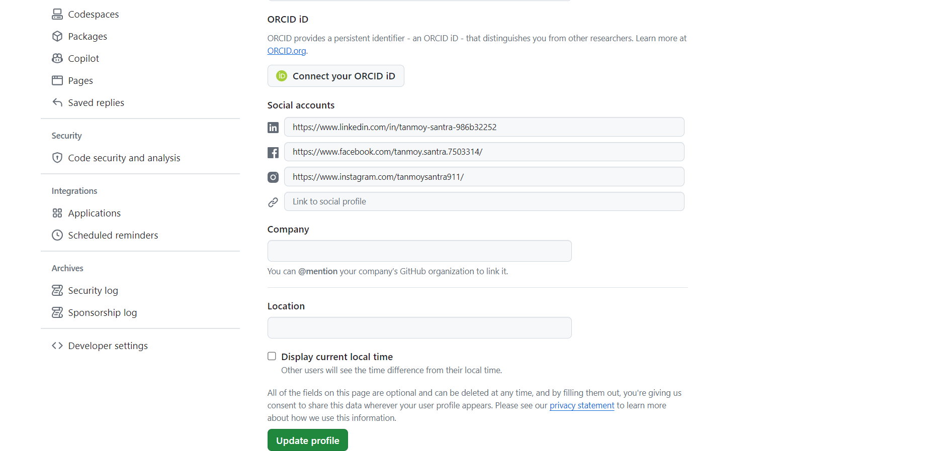

STEP 6- Select Tokens. Then select Generate New Token (Classic) option.

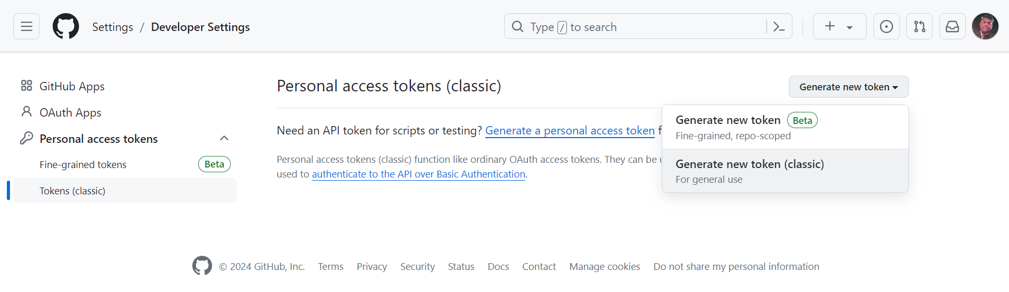

STEP 7- Write token name and set the Expiration to 90 days. Then click all the check boxes. Then

click Generate Token.

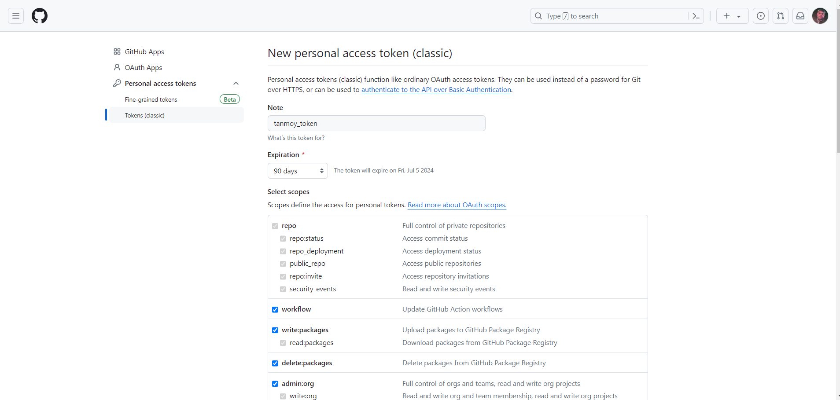

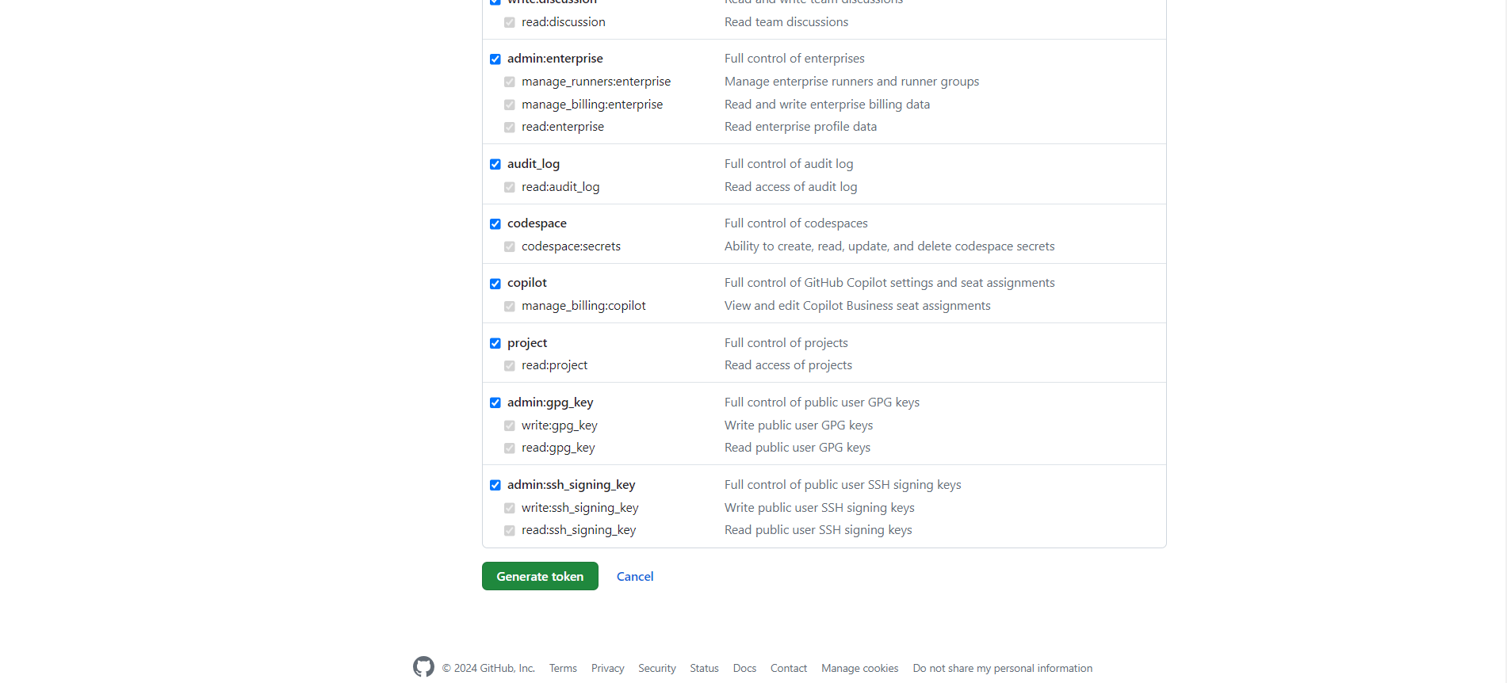

STEP 8- Token is created.

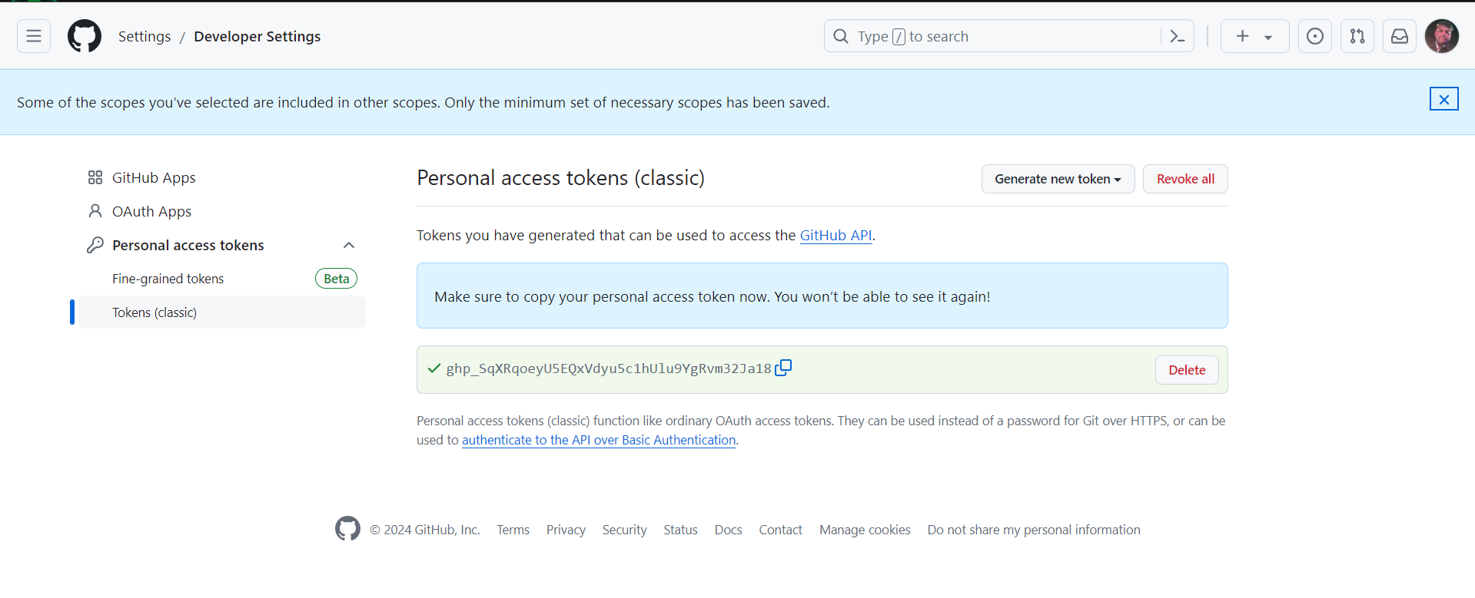

STEP 9- Right click on the folder and go to “show more options” then select “Git Bash Here”.

STEP 10- Type the following codes:

git init

git add .

git status

git commit -m done

git remote add origin

git push -u origin master

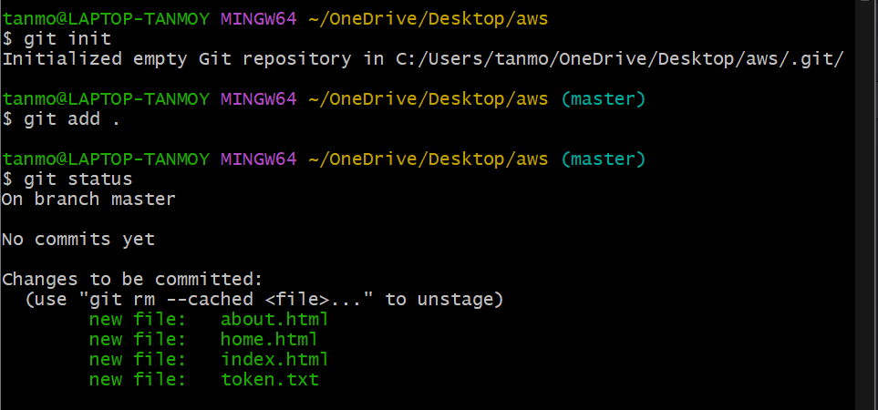

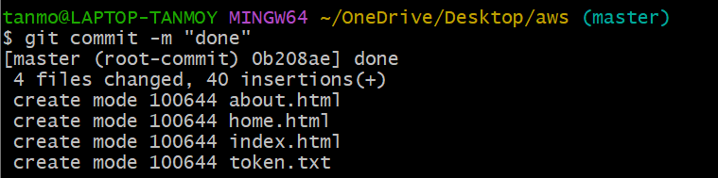

Copy the github repository link and paste it in git-bash



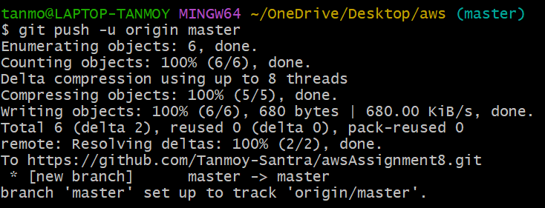

STEP 11- After that window appears, enter the token there.

STEP 12- Now check the GitHub repository. All the files will be uploaded there.

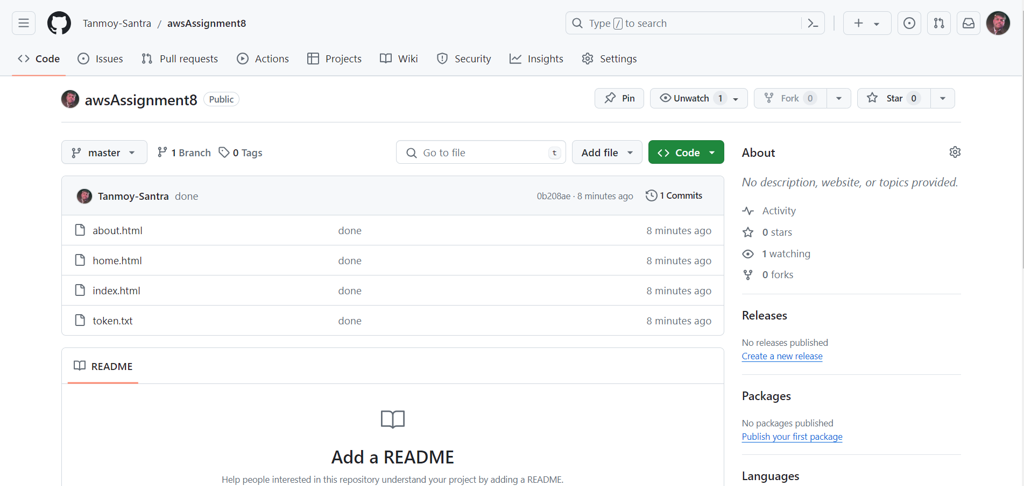

**To Download the Project from github**

STEP 1- Right click and go to show more options then select “Git Bash Here”.

STEP 2- In the git-bash terminal type

git clone --

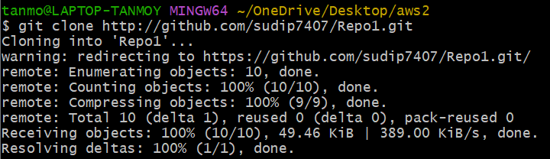

STEP 3- Open the folder and check.

